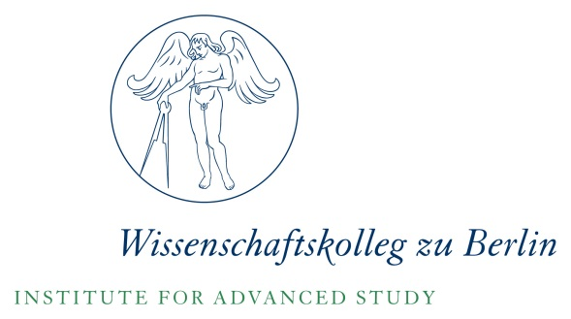

Colonial Agricultural Modernities: Capital, Concepts, Circulations

Day 1: Thursday, March 22
10:30 | Welcome: Daniel Schönpflug, Wissenschaftskolleg zu Berlin
10:30-12:00pm | Kris Manjapra & Sascha Auerbach, Introductions & Framing
12:00pm-1:30pm | Lunch
1:30-3pm | Session 1
 | Moderator: Daniel Schönpflug, Wissenschaftskolleg zu Berlin
 | Ulbe Bosma, International Institute of Social History/Vrije Universiteit Amsterdam
 |  | Enlightenment in the Global Periphery: Tropical Agricultural Innovation in the Age of Transition 1750s-1860s
 | Alberto Alonso Fradejas, Transnational Institute Leiden
 |  | The Rise of Agro-Extractive Capitalism in the Early 21st Century
3-3:30pm | Break
3:30-5pm | Session 2
 | Moderator: Dilip Gaonkar, Northwestern University
 | Sascha Auerbach, University of Nottingham
 |  | Race, Indentured Labour, and the Overseer State in the Nineteenth-Century British Empire
 | Preben Kaarsholm, Humboldt-Univeristät zu Berlin and Roskilde University, Denmark
 |  | From Abolition of the Slave Trade to Protection of Immigrants: Danish Colonialism, German Missionaries, and the Development of Ideas of Humanitarian Governance from the Early 18th to the 19th Century
5-5:30pm | Dilip Gaonkar, Closing remarks for Day 1
6:00pm- | Reception followed by dinner
Day 2: Friday, March 23
10:30-12:00pm | Session 3
 | Moderator: Vincent Houben, Humboldt Universität
 | Leida Fernández, CSIC Madrid
 |  | A Laboratory for Colonial Agricultural Modernity: Sugar and Slavery in Cuba from the 1750s to the 1870s
 | Ulrike Kirchberger, Universität Kassel
 |  | Ecologies beyond the Plantation Economy: Biochronologies in the Indian Ocean World, 1850-1920
12:00-1:30pm | Lunch
1:30-3pm | Session 4
 | Moderator: On Barak, Tel Aviv University
 | Rachel Kurian, Erasmus Graduate School of Social Sciences and the Humanities
 |  | The Industrial Plantation under Colonialism in South Asia: Finance Capital, Price Takers, and Labour Regimes
 | Kris Manjapra, Wissenschaftskolleg zu Berlin and Tufts University, Boston
 |  | Forms of the Multinational in an Axial Period: Force, Race, and Finance on Colonial Agro-Industrial Frontiers, 1830-1890
3-3:30pm | Break
3:30-5pm | Session 5
 | Moderator: Andreas Eckert, Humboldt Universität
 | Zach Sell, Brown University
 |  | U.S. Settler Slavery in Imperial Perspective
 | Claiton da Silva, Universidade Federal da Fronteira Sul/Federal University of Southern Frontier
 |  | Conquering the Brazilian Cerrados: Shaping an Agricultural System for Global Savannas
5-5:30pm | Ulbe Bosma and Andreas Eckert, Closing Remarks
5:30-6:30pm | Discussion
7:00pm- | Dinner

If you are interested in attending the workshop please contact Corina Pertschi until 16 March: corina.pertschi@wiko-berlin.de, Tel.: 030 /89001-158

